US Sales Force
Promotion Mix & Optimization Process Documentation

Promotion Response Team
Sales Force Operation
June 2005

Contents

- Introduction

  - Promotion Response & Mix Optimization Flow Chart

- Data Structure and Preparation

1. Data Collection & Validation – put the description of the variables collected
PRM – data collection from the external sources.
US Answers
LPM

- Cluster Analysis

II-1. Brand Equity Analysis --Attitude Cluster Variable
1. Data Validation
- Classify Samples by Cluster
- Projection of Attitude Cluster to the population using Behavior Analysis
II-2. Behavior Analysis --Behavior Cluster Variable
- Behavior Data preparation
- Classify Population by Behavior Cluster
II-3 Detailed Process to Select Cluster Variable

- Promotion Mix Model
Model Structure
1. Model Specification Explore – make sure that the current model is described
- Fitting the Proc Mixed Model
Model Validation

- Hold out analysis
---Add to each chapter a list of potential things to improve/test

- Change management process. – use the process change priorities list

- Promotion Optimization

1. Communicate cross-function to collect business assumptions
2. Optimization Objective Function
3. Integration Constrains to optimization
4. Output & Business Decision Support

- Competitive Analysis
1. Collect and Validate Data
2. Analyze Data
Targeting

- Appendix - put a user manual for promotion optimization

Appex-1 Summarized Mixed Model & Optimization Function
Appex-2 Details Specification by Products
Appex-3 Intervention types not in the model
Appex-4 More Details in Optimization & Interaction with Business Decisions

- Introduction and Purpose

Promotion mix is the analytical process used by LMR, SFS and marketing to reconcile spend level and message mix across different channels for all products as well as portfolio of products.

The purpose of this document is to institutionalize the technical process of promotion mix response analysis and promotion optimization to support for cross-brand call plan optimization and promotion mix allocation within each brand.

The document is trying to catch every detail of data process and utilization of technical methodology in order to provide guidance for internal knowledge transfer within SFO and capitalize organization learning.

For any other external communication purpose, the document could be considered as a technical reference only.

Data Structure and Preparation

Promotion Response & Mix Optimization Flow Chart

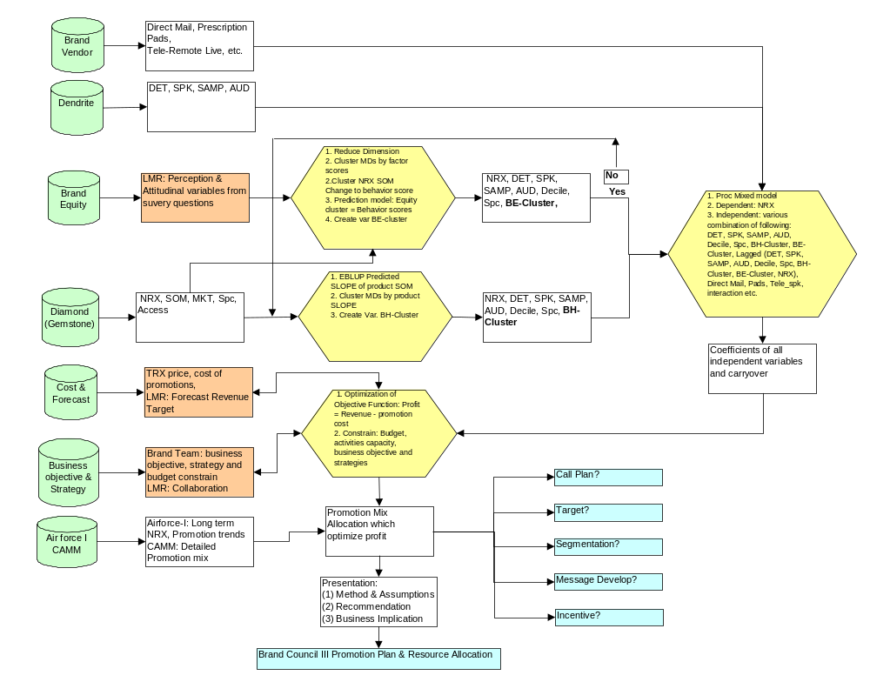
The flow chart illustrated all data sources and business input as well as intermediate output in every step in the whole process. The major data source includes:
A. NRX ----- Diamond & Gemstone.
  - DET, AUD, SPK ----- Dendrite: MD.RAW_DETAILS.
  - SAMP ----- MD.RAW_SAMPLES.
  - Deciles ----- Calculated based on Market NRX or collect from Diamond
  - Other Promotion Intervention ----- Brand Teams and Vendors.
  - Brand Equity Data & Forecasting ------ Lilly Market Research.
  - Promotion Cost Assumptions ----- Brand Teams and Financial Department.
  - Competitive Data ----- CAMM & Air Force I (IMS).

Data Collection & Validation

A. Reorganized data by subject (MD) and time .
B. Merge NRX, DET, AUD, SPK, SAMP.
- Delete subjects not detailed (eg. less than 1 or 2 DETs in single month during 24 month).
- Validate and process brand equity data
E. Subset data NRX (10%) for model calibration & development.
- Merge behavior cluster or brand e cluster with NRX and promotion data set for modeling.
- Collect & validate promotion cost, revenue forecasting
- Align constraints, business strategy, objective, promotion activity and budget constrains for promotion mix optimization

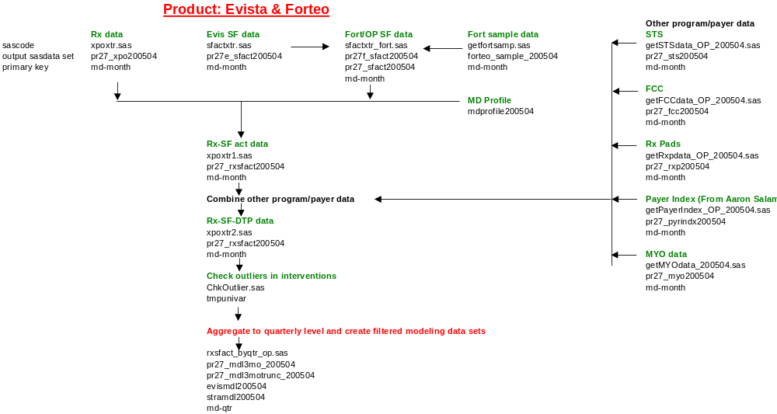

3. Mix Model Structure

Dependent Variable (NRX) = lag(NRX) + Common Promotion Variables (DET, AUD, SPK, SAMP) + Other DTP Variables (ex: Prescription Pads, Direct Mail, Remote SPK) + Cluster Variable (ex: Deciles, Behavior Cluster, Attitude Cluster)

Cluster Analysis – goes to appendix

II-1. Brand Equity Analysis --Attitude Cluster Variable

The step is used to classify population into various attitude clusters based on brand equity survey through behavioral projection. Brand Equity is defined as “the differential effect that brand knowledge (awareness, associations, quality and loyalty) has on the consumer response to the marketing of a brand. MDs whose perceptions about brands, product features, product attributes based on LMR Brand Equity Research would affect their prescription behavior and responses to promotion activities. Attitude cluster variable is used to classify MDs based on Brand Equity Analysis, and then build a model that could predict attitude cluster by prescription behavior. – goes to Appendix

1. Data Validation

A. Sample adjustments to insure representative to population behavior.
B Eliminate variables with extremely lower responses or without awareness (It will cause singular matrix in later analysis stage).
D. Recode Missing data to neutralize cluster impact (mean or other imputed value), may re-code variables with reverse questions.
F. Standardize variables to eliminate distortion of large-scale variables.

2. Classify Samples by Cluster

A. Principle Factor Analysis to reduce variable and identify key dimensions that affect MDs percentage about brand and product attributes.
B. Cluster Analysis uses key dimensions (factor score) generated from previous step to classify MDs into a few groups that are differentiated by their perception of product attributes and brands.
C. Discriminant Analysis establishes a prediction model between assigned clusters and key dimensions (latent variable). It can be used to interpret consistent of questionnaire variables and latent variables.
D. Stepwise Discriminant (Optional) can be used to predict assigned cluster by key questionnaire variables rather than key dimensions. It could establish direct linkage between questionnaire variables and Attitude clusters.

3. Projection of Attitude Cluster to the population using Behavior Analysis

- Using NRX of all major products and market total NRX from previous stage to create SOM.
- Mixed Model and EBLUP to predict SOM for major products in that market at MD level.
- Calculate SOM change by first order differencing to generate SOM slope for each product at MD level (Mixed model is linear model on time, the difference between each period is equal SOM slope, i.e. SOM change).
- Develop model within brand equity sample set to project Brand Equity cluster (assigned previous step) by behavior score (SOM changes are key components for behavior score).
- Apply projection model to population and assign a cluster to each MD in population set.
D. The BE-Cluster variable will be independent variable similar to segmentation variable or deciles variable in mixed model.

II-2. Behavior Analysis --Behavior Cluster Variable

Create a "Cluster Variable" reflecting prescription behavior if Brand Equity Cluster variable is not available. Behavior cluster is based on SOM change for all major products to measure competitive product switching. The clusters would be classifying MDs who may view brand equity differently and respond to promotion differently.

1. Behavior Data preparation
- Using NRX of all major products and market total NRX from previous stage to create SOM for each product.
- Transpose SOMs as single variable for each product with Time & ID variable.
- Mixed Model and EBLUP (empirical best linear unbiased predictor) to predict SOM for major products in that market at MD level.
- Calculate SOM change by first order differencing to generate SOM slope for each product at MD level (Mixed model is linear model on time, the difference between each period is equal SOM slope, i.e. SOM change).

2. Classify Population by Behavior Cluster

A. Organize SOM change for all products at MD level in that market as the key components.
B. Cluster Analysis to classify MDs into Behavior-Cluster based on major product SOM slopes.
C. The BH-Cluster variable will be independent variable similar to segmentation variable or deciles variable in mixed model.

II-3 Detailed Process to Select Cluster Variable

The following flow chart provides detailed guidance for the process to include brand equity cluster or behavior cluster in the model.
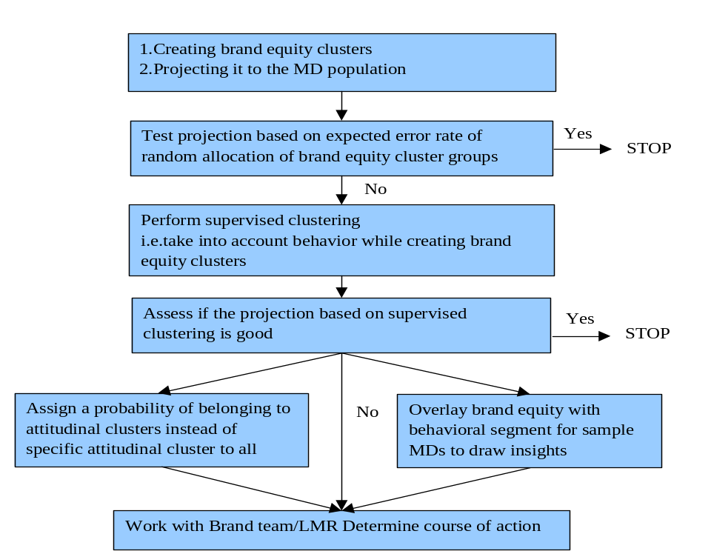

Promotion Mix Model

Extensive literature review was conducted to select statistical methodology for model development. Both generalized estimating equations (GEEs in PROC GENMOD) and Linear mixed model in PROC MIXED are explored because both of them have advantage to handle unbalanced data with unequally spaced time points and subjects observed at different time points. Obviously, any promotion activities are highly unbalanced at different time points. However, current data set could not converge in PROC GENMOD.

1. Model Specification Explore
- Conduct an exploratory data analysis by illustrating the cross-sectional and longitudinal relationships in the data;
- Identify theoretical framework what activities will be expected to influence MDs prescriptions.

2. Fitting the Proc Mixed Model

- Fit a complex mean model and select covariance structure through sample variogram.
- Eliminate unnecessary terms in the complex mean model to fit a parsimonious model.
- Finalize model structure and output co efficiency estimates for optimization.
- Evaluate model assumptions and identify potential outliers.

Promotion Optimization

Optimization is a key stage to integrate robust statistical analysis result with brand team’s business objectives and inputs to optimally allocate resources at right channel, right target and right promotion mix activities.

Communicate cross-function to collect business assumptions

- Financial Assumption: collect cost assumptions of all promotion activities & assumptions of revenue from Finance Department.
- Revenue Assumption: collect revenue forecast assumption for next plan year from LMR forecasting team.
- Brand Objective Assumption: Collect brand team assumption about business strategies, objectives, budget and specific constrains in terms budget, mix, channel etc.
- Other assumption: refill rate, number of MDs by segment, cluster in targeted population.

Optimization Objective Function

    - Objective Function: Maximize Profit = Revenue – Promotion Cost.
    - Revenue =Incremental Nrx (response curve generated by promotion mixed model) * Refill Rate ( Trx/Nrx)*Calibfactor (1+growth rate in revenue forecasting)*MDs(by segment & cluster).
    - Promotion Cost =Incremental Cost by DET, SAMP, SPK* total DET, SAMP, SPK etc.

Integration Constrains to optimization
    - Activities capacity (range) constrains: Certain promotion activities will be constrained by its capacity.
    - Budget constrains: Overall available budget for the brand and strategic budget allocation for long-term business objectives.
    - Revenue constraint: forecasting revenue for detailed segments.
    - Targeted segmentation constrains: Strategic targeted segments with pre-allocated resources.

Output & Business Decision Support
    - Integrated analysis (competitive analysis, brand equity analysis, promotion response analysis, optimization analysis) and interpret findings and business implication.
    - Two way communication with LMR, Brand Team and Sales Force Administration to integrate finding with business decision.
    - Provide analysis inputs for call plan, segmentation, target and Brand Council III promotion planning.

Competitive Analysis

Theoretically, competitive promotion activities are supposed included in model structure because MDs are influenced by promotion activities simultaneously from all market players. However availability constrain of competitive promotion data at physician level limit competitive analysis only at a qualitative reference for decision support. It is not necessary to update by quarterly

Collect and Validate Data
    - NRX, promotion historic data from Air force I for major competitive products (IMS data).
    - Promotion mix from CAMM (with my detailed classified promotion data).
    - Verify and consolidate two data source in a consistent manner.

Analyze Data

    - Compare & analyze efficiency and effectiveness of promotion activities among competitive products.
    - Compare & analyze promotion mix composite weight among competitive products.

Appendix

Appex-1 Summarized Mixed Model & Optimization Function

1. Mix Model

Mix Model: Ln(NRX_{t} +1) = β₀ + λ * Ln (NRX_{t-1} +1) + β₁ * DET + β₂ * SAMP
+ β₃ *AUD + β_{4 *} SPK + …;
Where DET --- Ave. No. of details by month
SAMP ---Ave. No. of samples by month
AUD --- Ave. No. of Sample by Month
SPK ---Ave. no. of Sample by Month
T ---12

Ln(NRX_{t} +1) = β₀ + λ * Ln (NRX_{t-1} +1) + Σβ_{i} * Pi
Where P_{i} = Promotion and Interactions (Det, Samp, etc.)

NRX_{t} +1 = e^{(β0 + Σβi * Pi)} * (NRX_{t-1} +1) ^{λ}
NRX_{t} = (NRX₀ +1) ^{λt} * e(β0 + Σβi * Pi) (1+ λ + λ2 + … + λt-1) - 1
Where NRX₀ = Historic Average NRX /Month/MD

Incremental: Δ NRX_{t} = NRXt (Σβi * Pi) – NRXt (0)
Where NRX_{t} (Σβi * Pi) --- NRX with promotion activities
NRX_{t} (0) ---- All promotion activities are zero

Δ NRX_{t} = (NRX₀ +1) ^{λt} * (e(β0 + Σβi * Pi) (1+ λ + λ2 + … + λt-1) - e^{(β0 ) (1+ λ + λ2 + … + λt-1)} )
=NRX_term * (e^{(β0 + Σβi * Pi) *Tlag} - ^{β0 )} - e^{(β0 ) *Tlag})
Where NRXt_term = (NRX₀ +1) ^{λt}
Tlag = (1+ λ + λ2 + … + λt-1)

2. Optimization

Objective Function: Max = Σ Δ NRX_{t *} R * F * SC_{ij} - ΣC_{k} * P_{k}

Where R ---- Refill Rate (Historic Average TRX/NRX);
F ---- Calibration Factor ( Revenue in planned year/Revenue in current year);
Sij---- Number of MDs by segment (i) and by cluster (j);
C_{k} ---- Average Cost of promotion activities (DET, SAMP etc.);
P_{k} -----Number of promotion activities
Appex-2. Details Specification by Products
 | Differences in methodology
Process | Zyprexa | Evista/Forteo/Cialis | Strattera
Segmentation
Brand Equity | Brand equity cluster assigned to all MDs in the universe (Projected by latent variables for attitude and behavior) | Small sample (N=300) enabled only an overlay of BE cluster with behavioral cluster | Sample brand equity cluster not projectable to MD universe
Used in response models | Yes | No | No

Behavioral
Share | Based on mixed model with SOM in market as dependent variables | Same as Zyprexa | Based on aggregate share change between two period and volume (Not used finally)
Volume | Decile grouping | Decile grouping | Decile grouping (ADD and ADP)
Payer Access | Plan variable as covariate | Not used | Not used

Mixed Model
Fixed effect | Yes | Yes | Yes
Random effect | Yes | Yes | No
Lag terms | Activity for either t or t-1 | Activity for t and t-1 | Only activity for t
Form of sample term | Samples | Samples | Samples/Detail
Time trend variable | Yes | Yes | No
Choosing interaction terms | Systematic | Systematic | Less systematic

Appex-3. Intervention types not in the model

- DTC
- Missing programs
- Other DTP (Direct mail, Rx Pads etc.)
- Exhibits
- Journal Ads
- Payer Access
- e-Pharma

- DTC (MD level info not possible)
  - GRP at a geographic level (mostly by DMA)
  - Website activity at a geographic level (by state, city or DMA)
- Missing programs (MD level info)
  - Need to differentiate between Geo Opex and Brand Opex programs
  - From Jan 2004, SCN has smart ID for programs -> LLB data program ID --> Dendrite.
    - But many brand programs are not registered with LLB
    - If brand programs are registered with LLB, this would avoid counting all dendrite programs as Geo Opex programs
  - Currently, brand driven program information can be collected from Vendors who conduct the programs
- Other DTP (Direct mail, Rx Pads etc.) (MD level info)
  - Direct mail – Data from vendor who sent out the direct mail to MDs
  - Rx Pads – Data from vendor/Mediscripts
- Exhibits (MD level info not possible)
  - Most that can be hoped is the list of conference attendees where the exhibits are placed
- Journal Ads (MD level info not possible)
  - Based on Journal circulation/ shipment by geography
  - Journal subscriber list
- Payer Access (MD level info)
  - Brad’s method -MD level payer influence based on MD scripts across plans
  - Jesse’s method – MD Access Index based on product formulary status
- e-Pharma (MD level info)
  - From Dendrite based on resp codes, TeleWeb vendor
  - Lilly/Connect

Appex-4. More Details in Optimization & Interaction with Business Decisions

Optimization

The goal of optimization in the context of promotion mix analysis is to optimally allocate resources across different physician groups and marketing channels to maximize profit while meeting any operational and business constraints. The levers (referred to as decision variables in optimization terminology) that can be pulled to maximize the profit (referred to as objective function in optimization terminology) are the levels of different type of interventions (such as details, samples etc.) to different groups of physicians. A conceptual representation of the optimization framework is illustrated in Figure 1.

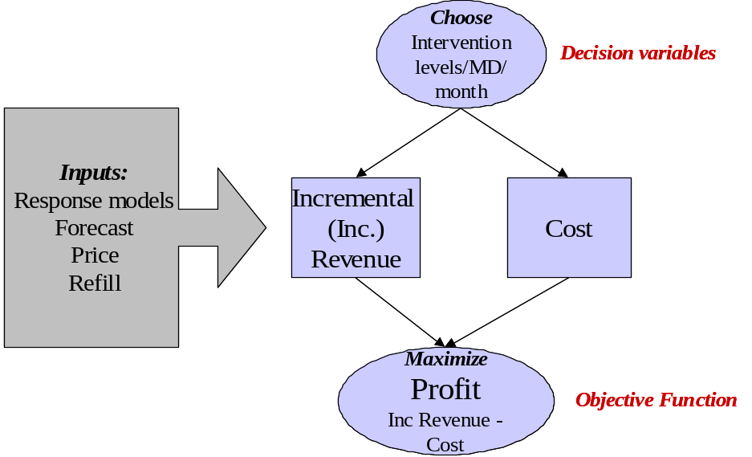

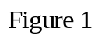

Next, the detailed relation of profit to level of interventions across target groups and channels is described. The physician group description is brand specific. For example, the physician groups for Strattera are a combination of Adult versus Child physicians and specialty whereas for Evista the physician groups are a combination of bone decile groups and specialty. The promotional channels are common across brands (Details, samples, Audio program, Speaker Program, Brand Program, Remote Live, DTC etc.). For simplicity of description, it is assumed that there are three physician groups (1, 2, 3) and three channels (details, samples, programs).

Inc Revenue Calculation

Since there are three groups (1, 2 and 3), the total incremental revenue is:
Inc Revenue=Inc Revenue₁+Inc Revenue₂+Inc Revenue₃
where Inc Revenue_{j} is the incremental revenue from MDs in group j. Inc Revenue_{j} is calculated based on number of MDs in group j, price per TRx, refill ratio, and response models as shown in Figure 2.

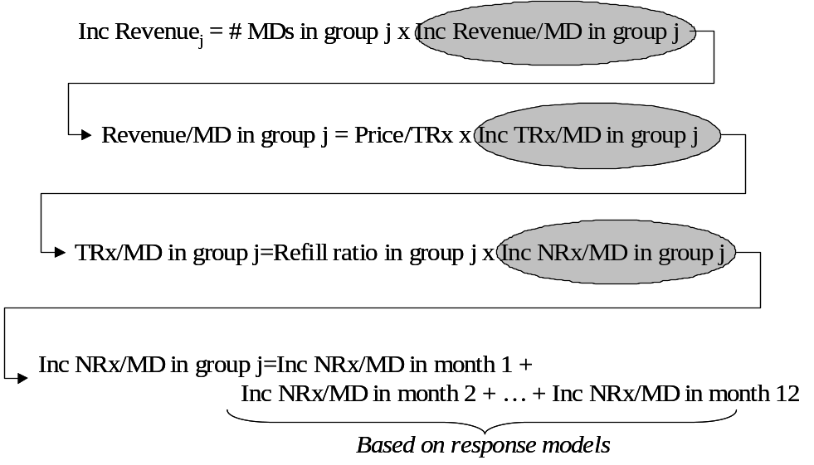

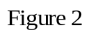

The calculation of NRx/MD for each month based on response models is detailed at the end of this section. Finally, the Inc Revenue is calibrated to forecast using a calibration factor that ensures that the forecast is met with historical effort levels.

Cost Calculation
Cost is calculated as:

Cost=Cost₁+Cost₂+Cost₃

where Cost_{j} is the cost incurred due to interventions in group j. Cost_{j} is calculated as:

Cost_{j}=Cost/MD/month for group j x # MDs in group j x 12
Cost/MD/month for group j = ( Intervention/MD/month x Cost per intervention) totaled over all intervention types (Channels)

In this example, there are only three types of interventions (Details, Samples, Programs) and therefore the cost/MD/month for group j is:

Cost/MD/month for group j=
Details/MD/month x Cost per detail + Samples/MD/month x Cost/sample + Programs/MD/month x Cost per program

Combining the above expressions for revenue and cost results in the following expression for profit:

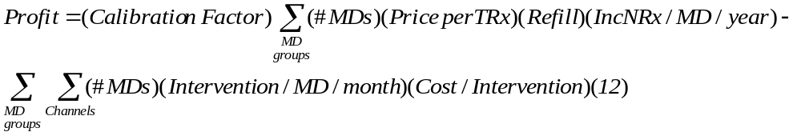

Operational Constraints:

Some of the operational constraints imposed in the model are:
- Maximum allowed/feasible interventions/month/MD. For example:
  - Max details/MD/month <= 4.5
  - Max samples/MD/month <= 18
  - Remote live program/year <= 1
- Maximum allowed details/sample to an MD
  - Samples/Detail <= 10
- Ranking of levels of different interventions
  - Details/MD/month >= Programs/MD/month

Business Constraints:
- Level of spend to certain targets groups. Eg:
  - Total spend on bone decile 7-10 MDs <= 110% of current spend on bone decile 7-10 MDs
- Mix of spend to certain target groups. Eg:
  - Spend on Adult Strattera targets/Total Spend >= 30%
- Level of spend to certain channels
  - Total detail spend <= 105% of current detail spend
- Mix of spend to certain channels
  - Total sample spend/Total spend <= 20%
- Constraint on target revenue
  - Target revenue=forecasted revenue

Calculation of NRx/MD/year from the response model

The response model models ln(NRx+1) at a monthly level using the following functional form:
where NRx_{t} is NRx in month t for an MD. Based on this functional form (and denoting f(interventions) by the symbol a), the expression for NRx in month t is:
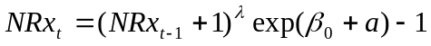
The incremental NRx in month t due to interventions is calculated by subtracting the NRx in month t with no activity (a=0).
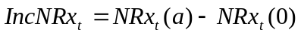
The Incremental NRx/MD for a year is calculated by assuming a starting average NRx/MD at time 0, same activity levels in each month and calculating each month’s IncNRx/MD based on the above formulas. The steps of this calculation are shown in Figure 3 below.
